Theia
Zaid Ibrahim
(zaidi92@gwmail.gwu.edu)
Final Project Report

Part 1 – Project Overview

In recent years, as businesses and individuals wish to spread word of their achievements, there is a greater demand for events to celebrate those accomplishments. Organizations are planning more events every year (the event industry has grown at an average pace of 6.2% each year since 2003) resulting in more work for event planners and interior decorators. With the increase in business, event planners are trying to find resources to help make their jobs easier. There are applications that allow a user to create a 2-D floor plan, such as RoomSketcher and Vivien, but event planners need a more competitive edge to succeed in this ever-growing industry and are looking to 3-D applications in order to meet those needs.
Designers are looking for the most effective way to display their events and consumers tend to prefer the most visually appealing product that a 3-D model can provide. Current 3-D event planning applications allow a user to build a floor plan and then display this floor plan in 3D. However, building a floor plan requires an extra amount of work for an already busy event planner. Some designers are in charge of multiple events, and in some cases these events are scattered around the country. When looking into resources to help you complete a job, you would rather have an application that helps you cut down on your workload rather than adding to it.
Using an application that allows an individual to scan a room and edit the room in 3-D space can help cut down on their workload. Scanning allows the designer to simply identify the room they wish to design and then edit the room from wherever they like. There are a few applications that do allow 3-D scanning but these applications require users to purchase a custom-made camera or use complicated software. These applications tend to be overly expensive due to the extra equipment that is needed to run them.
When looking for an application, users need more than an application that is automated to help cut down their workload. Users need an application that is affordable and convenient for them to use so that they can feel comfortable working. They also need an application that provides the best service for giving them the right software in order to get the job done correctly.
Theia is an application that satisfies these requirements. It is a 3-D rendering application designed to scan a room, allowing a user to design any room that they choose. It allows users to view any room from anywhere and with ease. Unlike other 3-D rendering applications, Theia does not need any special cameras or complicated software. Theia is designed to work by scanning images of a room that users take with their smart phones. It replicates rooms exactly how they should be based off of the information scanned from the images to provide users with the most realistic experience. Theia’s simple design allows users to create and design rooms with ease, making it the public’s room building application.

Part 2 – Technical Design

Theia is comprised of two components: a smart phone and a web interface. These components were chosen to help Theia achieve its easy to use design by letting the user use the resources they already have to successfully build and design a room.
When using their smart phone, the user is asked to take pictures of each corner of a room while attempting to include segments that are at least half the length of the walls making up that corner. Once the images are taken they can then upload these images by accessing Theia’s webpage. The webpage is designed to be simple and easy to follow to allow the user to quickly do their jobs. It is broken up into the Room Images page, the Room Customs page, and the 3D Model page.

Web Browser:
The web browser is supported using Node.js to create the server side interactions. The data is sent between webpages and stored using mysql commands. Javascript code is used to create the webpage interactions and to display the visuals needed in the Corner-Clicking algorithm. Three.js is the library used to create the three-dimensional objects and display 3D View. C++ is used to execute the algorithms used in the Image Scanner.
The Room Images page is the setting where users are able to upload images to create the foundation for their 3D model. The Room Customs page is for users who are unable to take images but know the dimensions of their room and can submit that information instead. In both of these rooms users can edit the wall color, upload a wall texture, and can view their corner data. The 3D Model page shows the user their virtual room models. While viewing the 3D model users can add objects to create any layout they choose, are able to edit object dimensions and position, and are able to take screenshots of their room.
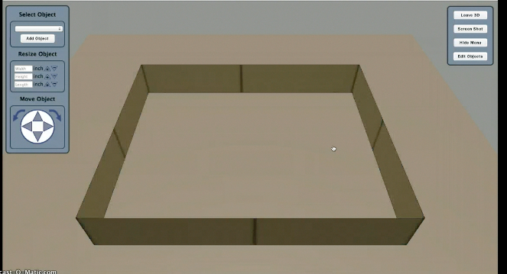
Image Processing:
Once a user has specified the room height and an image has been uploaded it is run through Theia’s image processor. The image processor is broken up into the Corner-Clicking algorithm and an image-scanning algorithm. Corner-Clicking has the user follow instructions to click specific areas in the uploaded image to identify the position of edges that make up the current corner. This data is then sent to the Image Scanner and is used to find the lengths of the 2-dimensional lines displayed in the image.
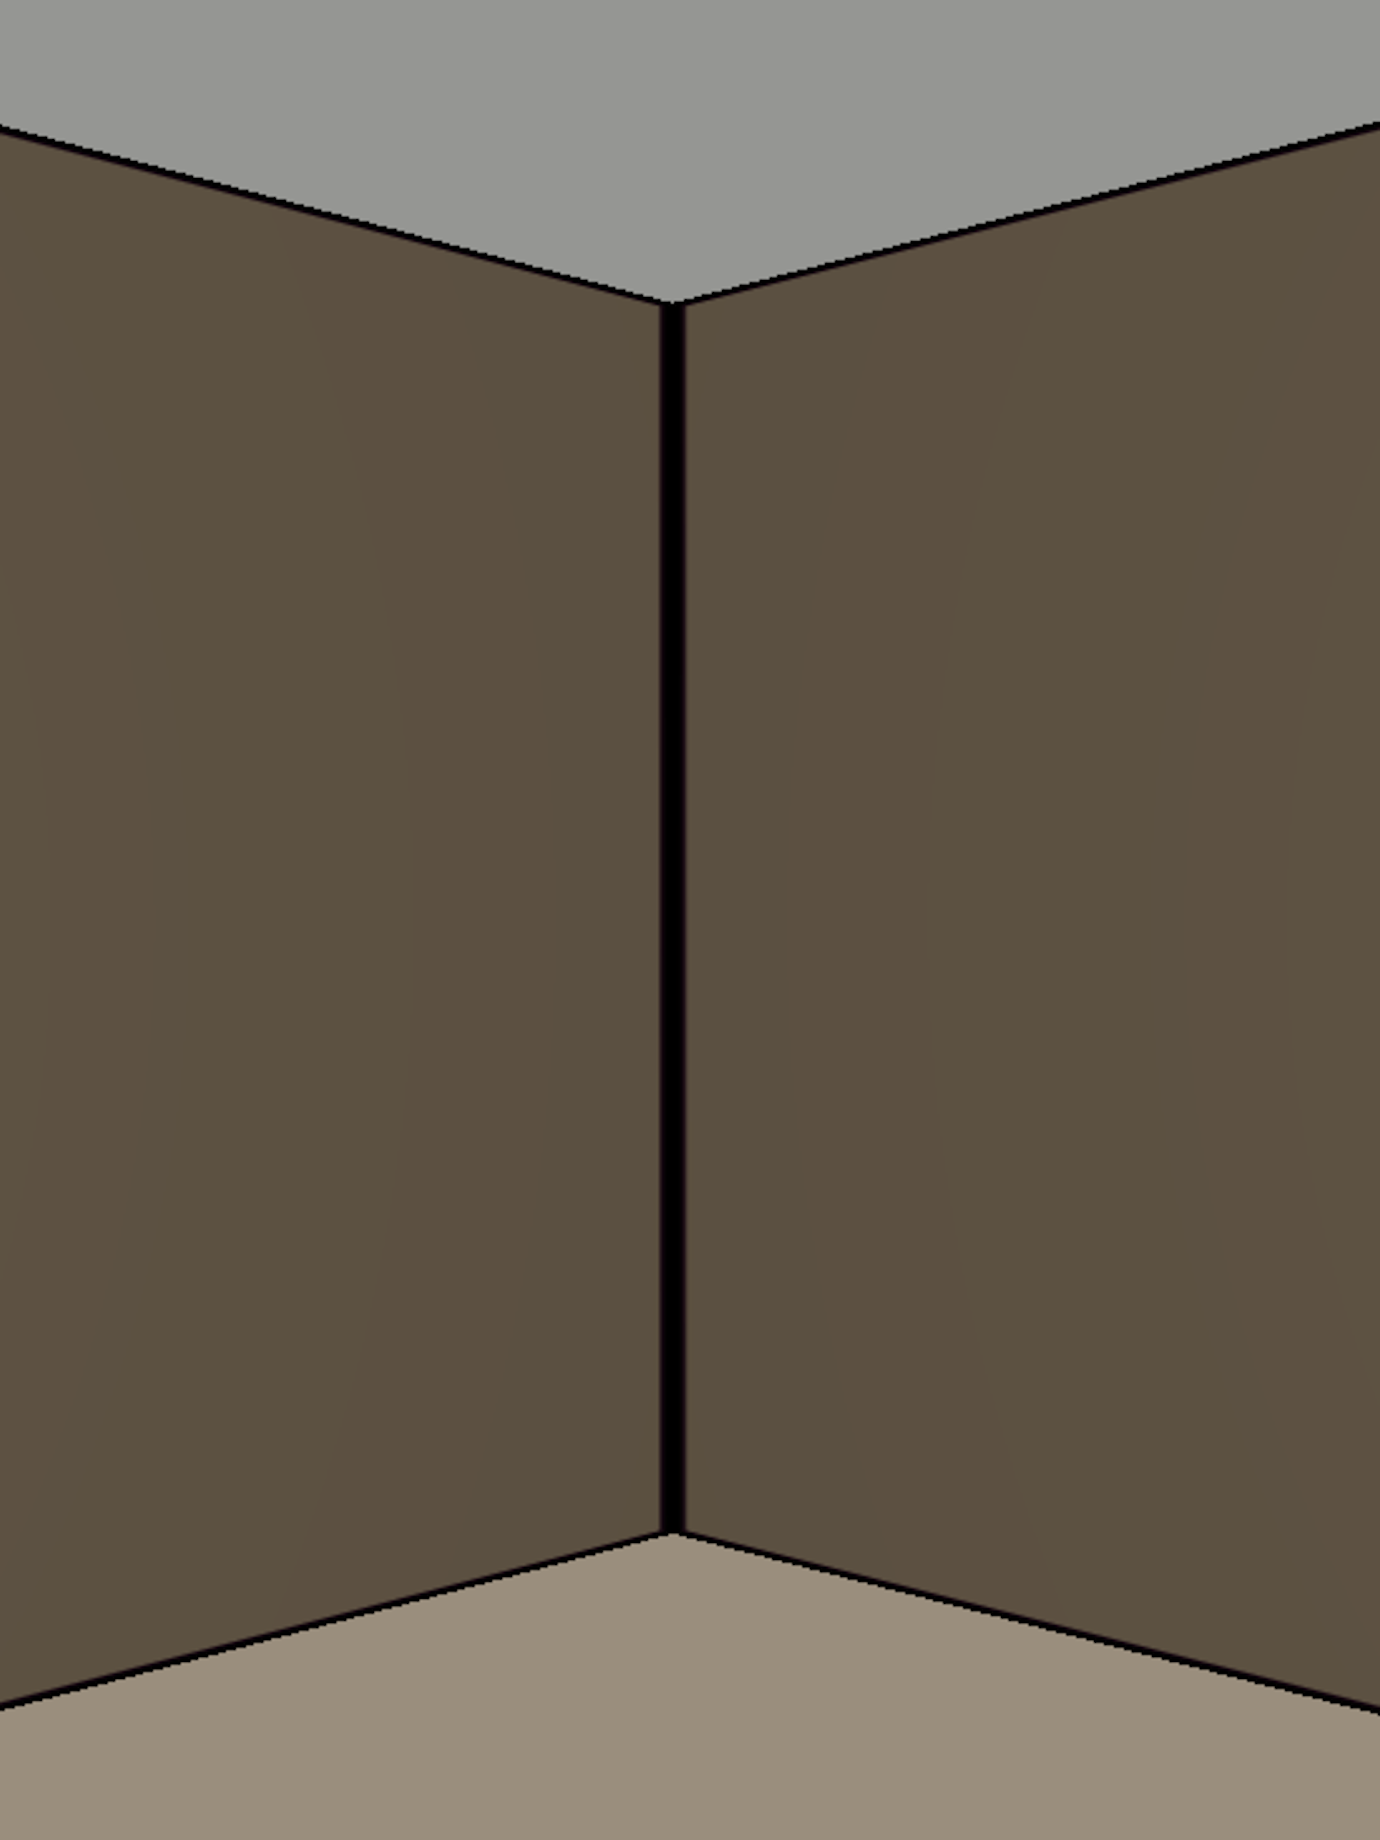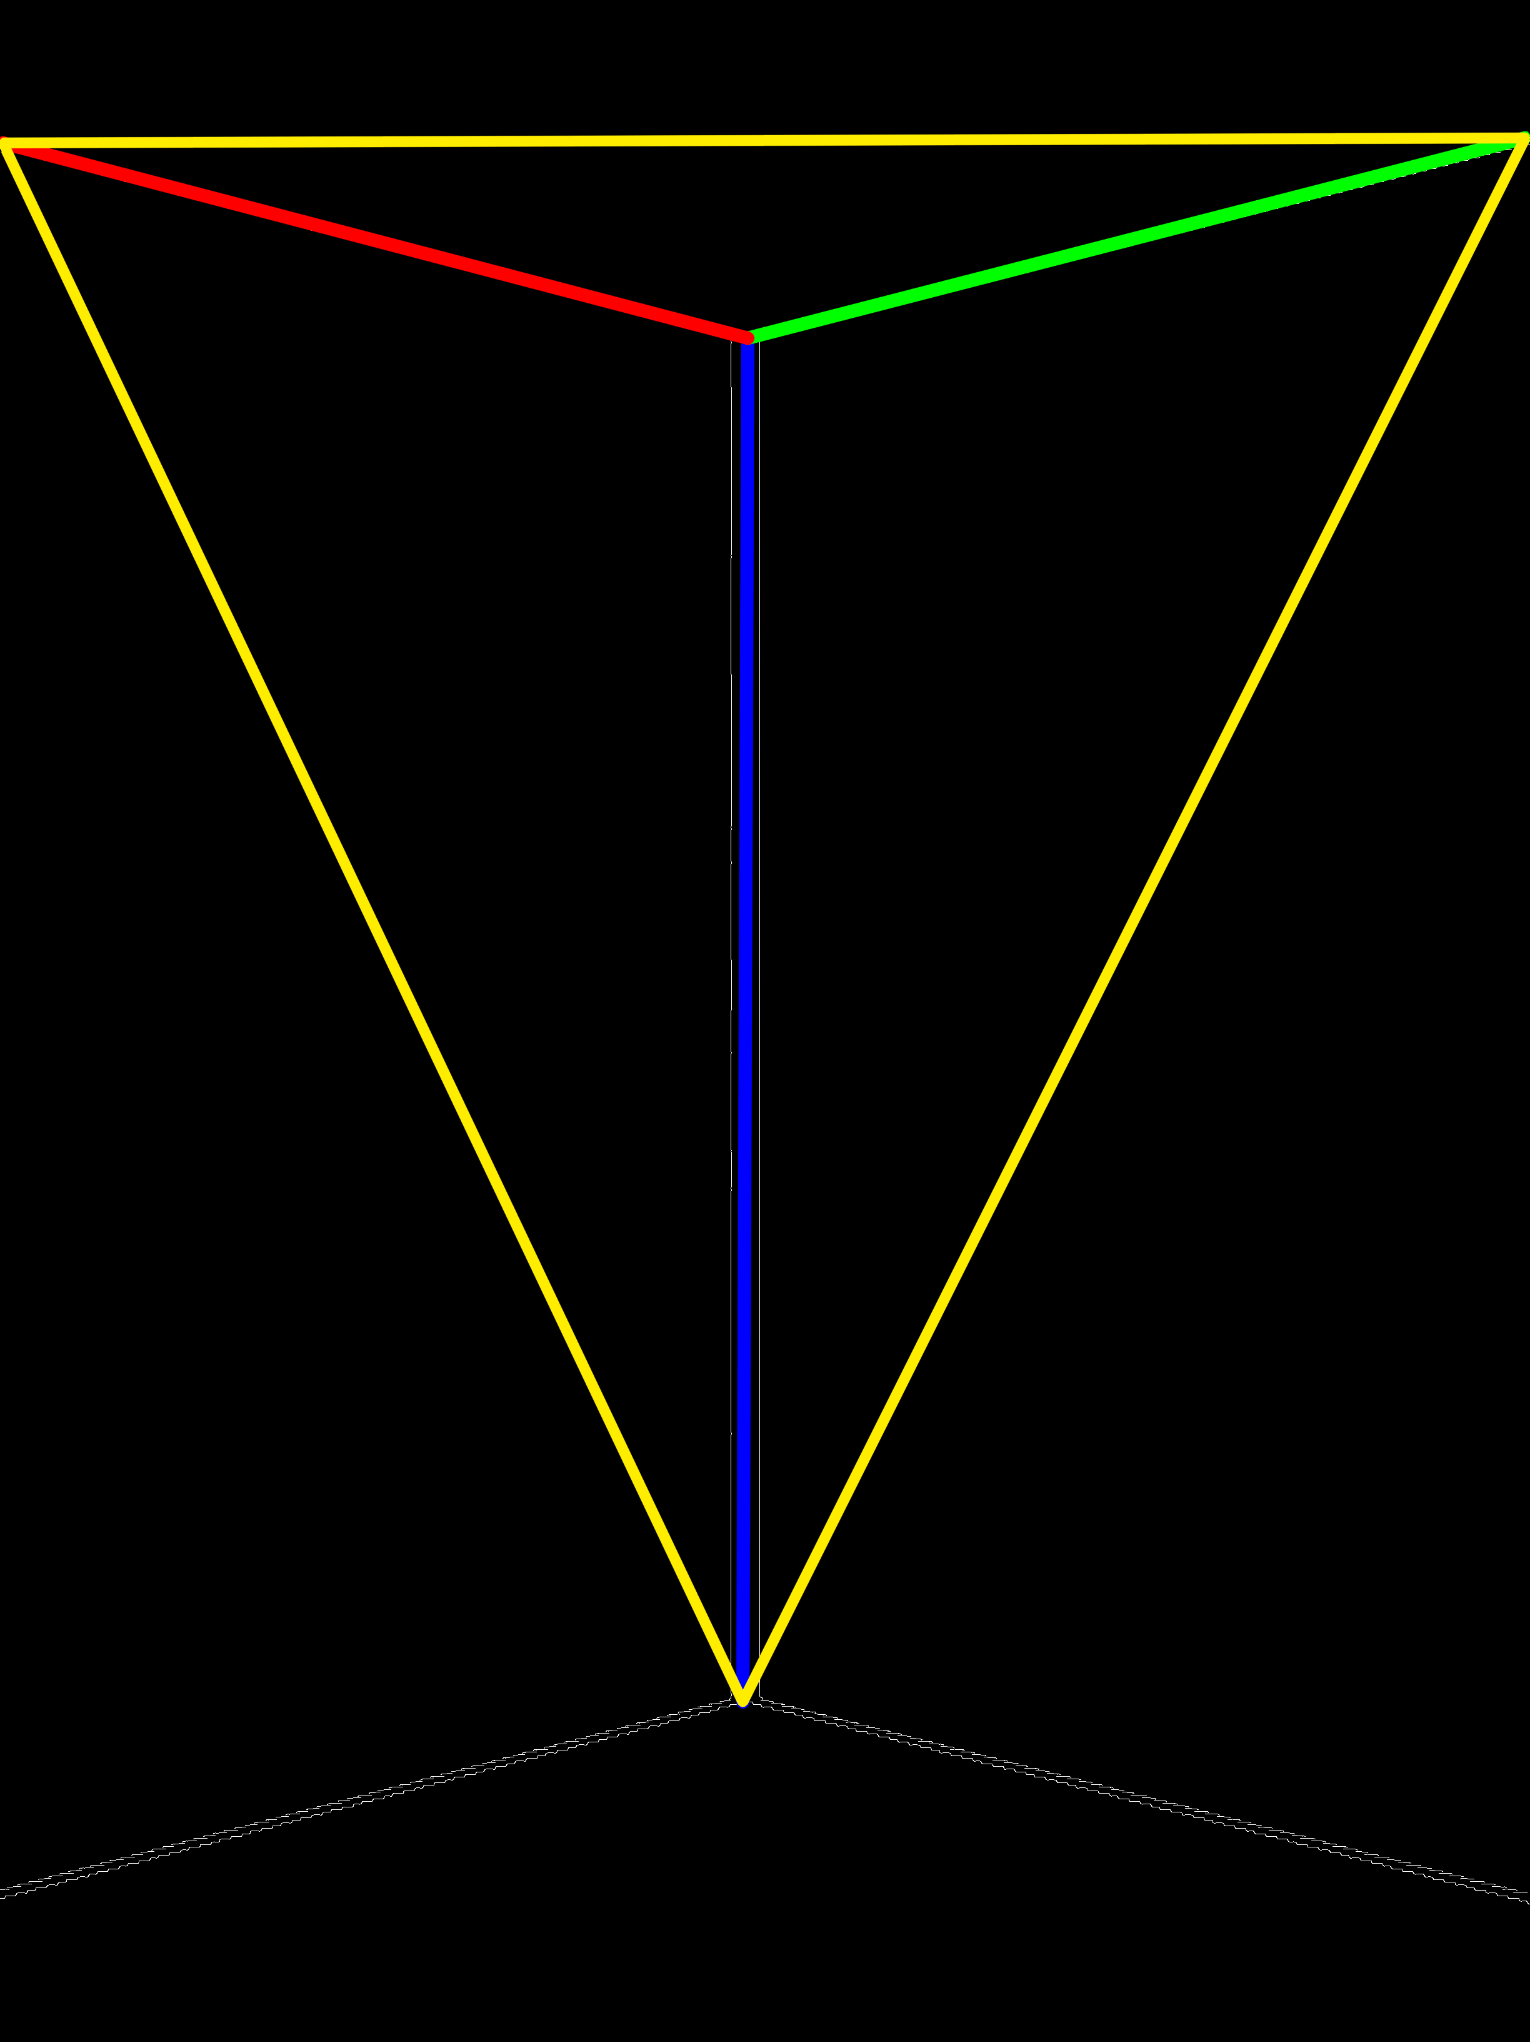
(Original Image) (Final Edited Image)
These lines are then run through a triangular pyramid algorithm that pulls these 2-D lines into 3-D space. The 3-D lengths calculated can be a different ratio than the dimensions that are actually needed. That is why the room height is submitted. It allows the algorithm to re-adjust the dimensions to their proper size. The lengths are specified as left length (green), right length (red), and height (blue) and are sent to Theia’s database by using mysql to transfer and update the room information.

Room Building:
Once the corners have been identified Theia’s image scanner builds them and positions them to create a basic 3D model. The algorithms needed to build the walls are found in WallBuilder.js. Here Theia uses the dimensions found in the Image Scanner to build each individual corner. In order for the Room Builder to work correctly the user needs to assume that the room is a basic convex geometry (ie. rectangle, triangle, pentagon, etc). The corners are then angled based off of the number of corners in the convex geometry (ie. 90 degrees if rectangular).
To position the corners correctly the lengths of the corners are used to find the correct distance from one another. By using the right length of the previous corner, the left length of the current corner and the angle specified by the geometry of the room the correct position for the current corner is found.
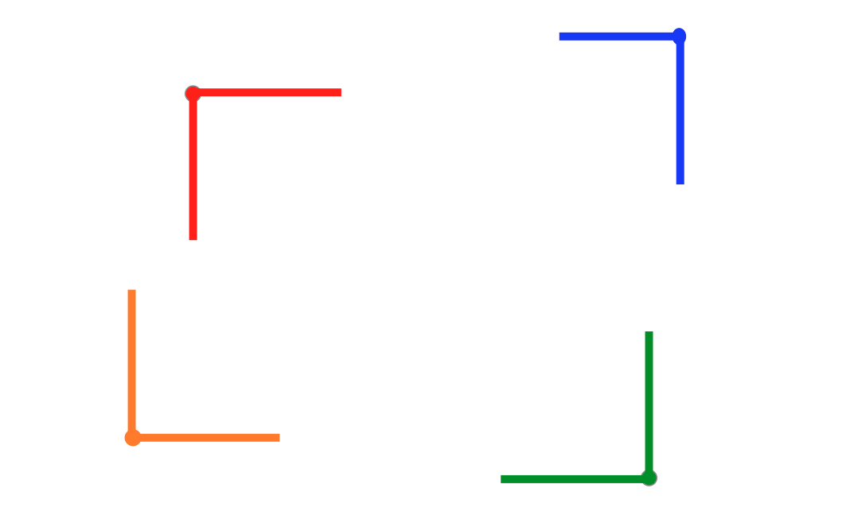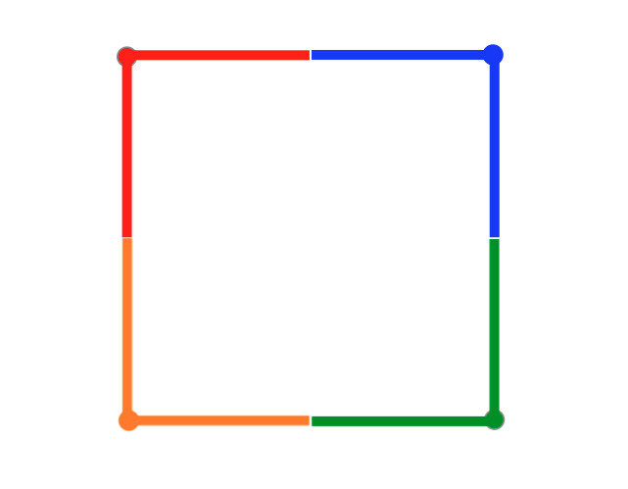
Before Corner Adjustments After Corner Adjustments
Due to human error when taking the pictures or when Corner-Clicking, the last corner may be slightly off. Theia takes this into consideration and adjusts the final corner to seamlessly connect it to the initial corner.

Object Creation
Objects are created using the Three.js library. The library allows the user to implement mathematical calculations to build simple geometry and connect them together to build chairs, tables etc. The dimensions specified in 3D mode are used to adjust the geometry that builds the objects in order to create the proper representation of that object. Each object is contained in its own js library and is referenced when creating the object in 3D mode.
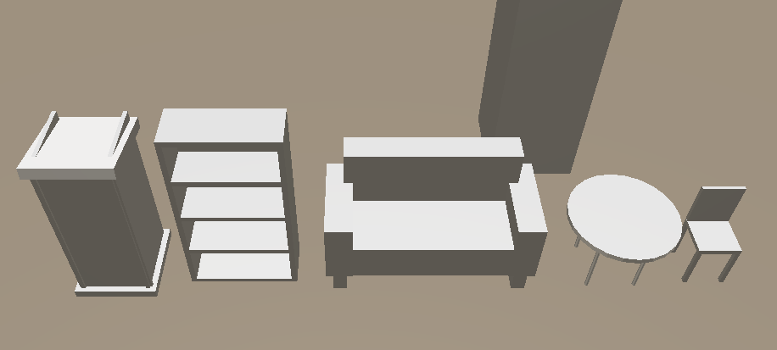

Part 3 – Project Development

In the initial development of Theia there were many difficulties. I was unsure how to start building the application and had the idea of building it into a phone app where the web interface was a supporting function. That direction did not work and ended up setting me back in the development process. I then moved to developing the web interface as the entirety of Theia. At the beginning I knew that I would use the Three.js library to create the visual interface but was unsure of how I would develop the image scanner.
I was introduced to OpenCV as an option to scan the image and search for the corner edges. OpenCV worked well for finding the edges when the edges were defined well. However, when using actual images of corners it was unable to find the proper wall edges that were needed. I ended up writing excess code that was unnecessary, altering the sections of the image that were scanned, taking the largest line that could be identified by OpenCV, and then using mathematical calculations that almost created the correct dimensions. After discussing other options to identify corners I decided that users would have to help Theia identify the proper corners. That is when I developed the Corner-Clicking algorithm.
The Corner-Clicker worked extremely well. It gave Theia the positions it needed to draw the correct lines and use those positions to find the 2-D lengths of the edges. I kept functions from OpenCV to create the black and white version of the image and to draw the lines on top of the image. Once I had edge detection down I needed to adjust the image scanners mathematical functions to create the proper dimensions. I ended up discussing different algorithms with a friend of mine, Richard Thurston, and developed the triangular pyramid algorithm that became the final version of the image scanner. With his help I was able to reduce a significant amount of my original code and was able to have the image scanner identify the difference between an outward facing corner and an inward facing corner.
During the initial image scanner phase I was able to develop the wall builders algorithm. It required a lot of alterations and discussing with multiple people to develop but it worked in the end. The wall builder takes into account corner angles and will be able to develop more complex rooms once the image scanner is able to calculate proper angles. As of now there is no proper way to identify the exact angle of a corner from a 2-D image. In the future if I was to continue working on Theia I would try to adjust and develop the algorithm to include the ability to identify the right angle for a wall corner.
During my time working on Theia I learned a lot about project management. Selecting the areas of a project that should be developed first hand is extremely important. It saves a lot of time and allows you to build the foundation of the project before implementing additional changes. I also gained experience when using Node.js in implementing servers and transmitting data. Both are important skills that are required when creating an application that is integrated with and used through a web browser.
If given the chance to go back and start developing Theia I would make multiple changes. I initially started out by trying to make a phone application but was unable to properly develop and test the phone app. I then moved to solely developing the web application and trying to use OpenCV. There was a large amount of time spent on trying to integrate OpenCV with Theia’s system and trying to create the mobile application. This is time that I could have used to finalize the web browser and develop the Image Scanner. I would have also discussed the mathematical calculations in more detail in order to avoid many of the mistakes I had made when initial trying to build the image scanner.

Part 4 – Future Growth

Theia has a lot of areas where it can be improved to give the user the best experience. The 3D side of Theia has a lot of potential in visuals. The objects in Theia are simple but can be adjusted to include more detail such as textures, color and more defined structures. The ceiling and floor designs are standard defaults but with some modifications users could add a specific texture or design to both of them to create a more realistic environment. The object library is designed to be flexible and easy to grow by adding new libraries for building objects.
As mentioned before the image scanner can be adjusted to include more detailed algorithms. In the future I plan to remove the Corner-Clicker altogether to remove a large step required to scan an image. I would also create a phone app that would allow the user to upload photos to Theia as soon as they are taken rather than having them save them to their computer and then upload them to Theia’s web browser. Theia is meant to be the easier way for individuals to design and create events and room layouts. The fewer steps required, the closer Theia gets to that goal.
Theia has a lot of potential in becoming one of the recommended applications for event planning and interior design. With the right marketing and the dedication to implement these extra features, I can see Theia being a brand name that many people will recognize and look forward to using.

References

[1] Publising Executive, Fast Stats : Events Industry Shows Consistent Growth, http://www.pubexec.com/article/events-industry-shows-consistent-growth-400439/1#

Publising Executive, Fast Stats : Events Industry Shows Consistent Growth, http://www.pubexec.com/article/events-industry-shows-consistent-growth-400439/1#

